Square Orthobicupola

Definition
# Source: AI Source: Provided by: [Data Path: Persons Table -> ID Column: 1, Name_En Column: Motasem Essam] -> From: [ChatGPT] on [7/25/2026]
A Square Orthobicupola is a convex polyhedron formed by joining two identical square cupolas at their octagonal bases, with both cupolas arranged in the same orientation.
It consists of:
- Two opposite square faces.
- Eight equilateral triangular faces.
- Eight lateral square faces.
- Two additional square faces forming the opposite ends.
The two octagonal bases are joined internally and are not counted as external faces.
The Square Orthobicupola is the 28th Johnson solid (J28).

Geometric Structure
# Source: AI Source: Provided by: [Data Path: Persons Table -> ID Column: 1, Name_En Column: Motasem Essam] -> From: [ChatGPT] on [7/25/2026]
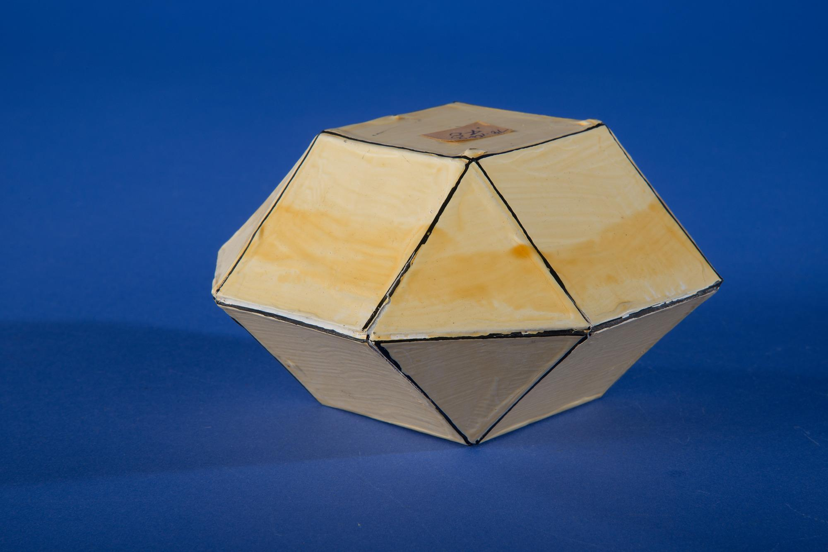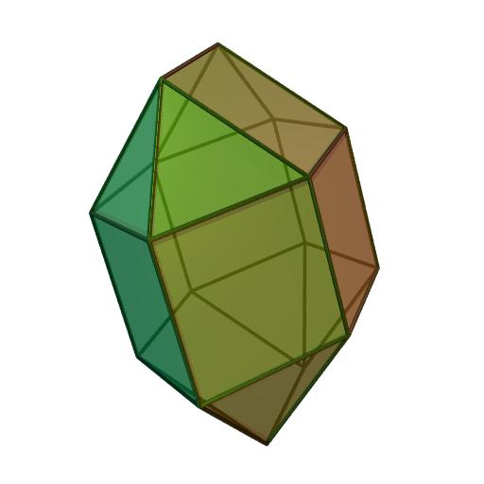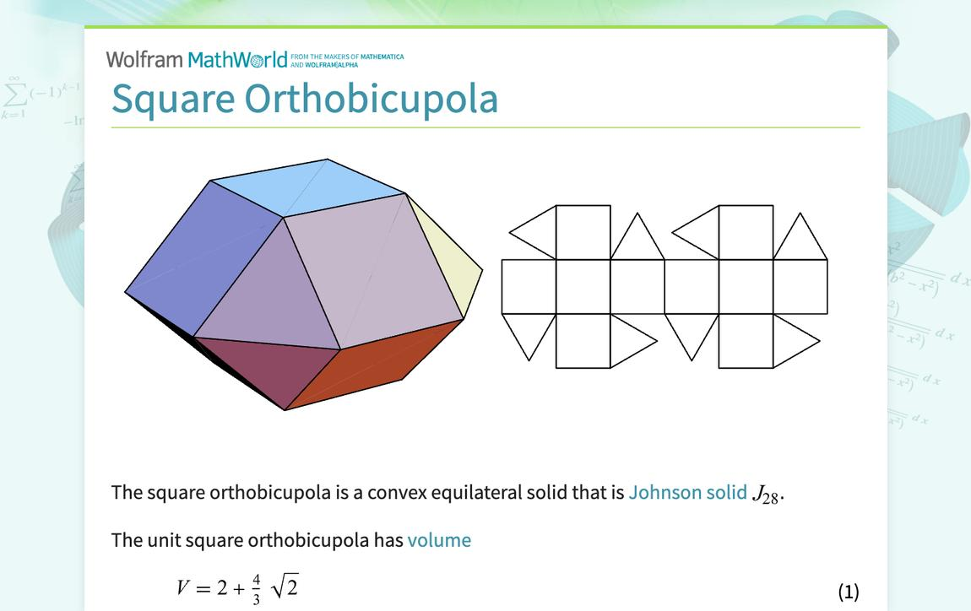
Its main elements are:
- Upper Square Face: The upper square face of the solid.
- Lower Square Face: The lower square face of the solid.
- Upper Square Cupola: The upper component of the solid.
- Lower Square Cupola: The lower component of the solid.
- Triangular Faces: Eight external equilateral triangular faces, four from each cupola.
- Square Faces: Ten external square faces, five from each cupola.
- Central Joining Region: The internal octagonal region connecting the two cupolas.
- Vertices: Sixteen vertices where the edges meet.
- Edges: Thirty-two edges forming the boundaries of the faces.
- Height: The perpendicular distance between the two opposite square faces.

Face Composition
# Source: AI Source: Provided by: [Data Path: Persons Table -> ID Column: 1, Name_En Column: Motasem Essam] -> From: [ChatGPT] on [7/25/2026]
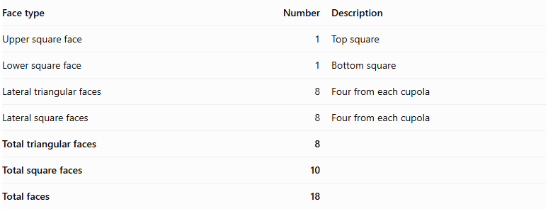
Face type | Number | Description
Upper square face | 1 | Top square
Lower square face | 1 | Bottom square
Lateral triangular faces | 8 | Four from each cupola
Lateral square faces | 8 | Four from each cupola
Total triangular faces | 8
Total square faces | 10
Total faces | 18
The two octagonal bases are joined internally and do not appear on the external surface.

Mathematical Properties
# Source: AI Source: Provided by: [Data Path: Persons Table -> ID Column: 1, Name_En Column: Motasem Essam] -> From: [ChatGPT] on [7/25/2026]
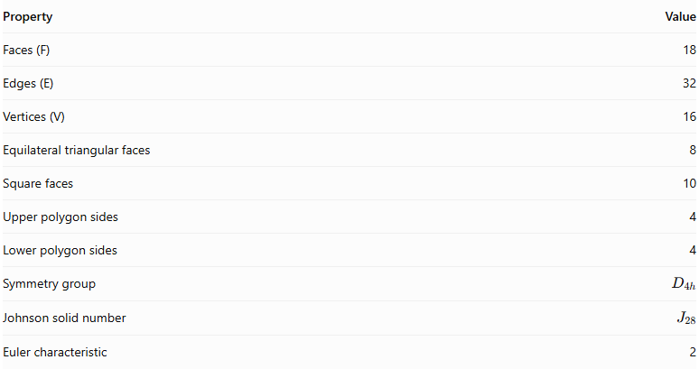
Property | Value
Faces (F) | 18
Edges (E) | 32
Vertices (V) | 16
Equilateral triangular faces | 8
Square faces | 10
Upper polygon sides | 4
Lower polygon sides | 4
Symmetry group | $$D_{4h}$$
Johnson solid number | $$J_{28}$$
Euler characteristic | 2
Euler's Formula:
$$V-E+F=2$$
$$16-32+18=2$$

Vertex Configuration
# Source: AI Source: Provided by: [Data Path: Persons Table -> ID Column: 1, Name_En Column: Motasem Essam] -> From: [ChatGPT] on [7/25/2026]
The Square Orthobicupola has two types of vertices:
- 8 vertices: Configuration $3.3.4.4$.
- 8 vertices: Configuration $3.4.3.4$.
Here, 3 represents a triangular face and 4 represents a square face. The notation describes the faces surrounding each vertex in cyclic order.

Surface Area
# Source: AI Source: Provided by: [Data Path: Persons Table -> ID Column: 1, Name_En Column: Motasem Essam] -> From: [ChatGPT] on [7/25/2026]
For an edge length $a$:
$$S=8(\frac{\sqrt{3}}{4}a^{2})+10a^{2}$$
$$\boxed{S=(10+2\sqrt{3})a^{2}}$$

Volume
# Source: AI Source: Provided by: [Data Path: Persons Table -> ID Column: 1, Name_En Column: Motasem Essam] -> From: [ChatGPT] on [7/25/2026]
For the regular Square Orthobicupola:
$$\boxed{V=(2+\frac{4\sqrt{2}}{3})a^{3}}$$
For a unit edge length ($a=1$):
$$V≈3.8856$$

Geometric Characteristics
# Source: AI Source: Provided by: [Data Path: Persons Table -> ID Column: 1, Name_En Column: Motasem Essam] -> From: [ChatGPT] on [7/25/2026]
- It is constructed from two identical square cupolas.
- The two cupolas are joined at their octagonal bases.
- Their orientations are aligned.
- It has two opposite square faces.
- It contains eight equilateral triangular faces.
- It contains ten square faces.
- It has 18 external faces.
- It has 32 edges.
- It has 16 vertices.
- It is a convex polyhedron.
- It has dihedral symmetry $D_{4h}$.
- It has two different vertex configurations.

Construction of a Square Orthobicupola

Geometric Instruments Used
# Source: AI Source: Provided by: [Data Path: Persons Table -> ID Column: 1, Name_En Column: Motasem Essam] -> From: [ChatGPT] on [7/25/2026]
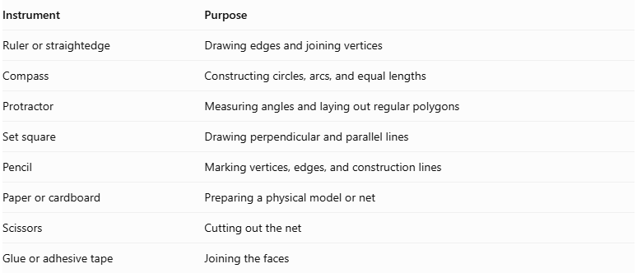
Instrument | Purpose
Ruler or straightedge | Drawing edges and joining vertices
Compass | Constructing circles, arcs, and equal lengths
Protractor | Measuring angles and laying out regular polygons
Set square | Drawing perpendicular and parallel lines
Pencil | Marking vertices, edges, and construction lines
Paper or cardboard | Preparing a physical model or net
Scissors | Cutting out the net
Glue or adhesive tape | Joining the faces

Instrument-Based Construction Procedures

Construct the Two Square Cupola Components
# Source: AI Source: Provided by: [Data Path: Persons Table -> ID Column: 1, Name_En Column: Motasem Essam] -> From: [ChatGPT] on [7/25/2026]
- Draw two congruent regular octagons using a compass, ruler, and protractor.
- Construct a square above each octagon, using the standard square-cupola arrangement.
- Arrange the eight lateral faces around each octagon:
- Four equilateral triangular faces.
- Four square faces.
- Ensure that the triangles and squares alternate around the octagonal boundary.
- Repeat the construction with matching dimensions for the second cupola.

Join the Cupolas
# Source: AI Source: Provided by: [Data Path: Persons Table -> ID Column: 1, Name_En Column: Motasem Essam] -> From: [ChatGPT] on [7/25/2026]
- Place the two octagonal bases opposite one another.
- Align their octagonal edges and corresponding vertices.
- Join the two cupolas along the octagonal bases, keeping the square faces in the orthobicupola arrangement.
- Treat the joined octagon as an internal face; it must not appear on the exterior.
- Check that the lateral faces meet edge-to-edge without gaps or unintended overlaps.

Complete the Solid Drawing
# Source: AI Source: Provided by: [Data Path: Persons Table -> ID Column: 1, Name_En Column: Motasem Essam] -> From: [ChatGPT] on [7/25/2026]
- Draw the two exposed square bases at opposite ends.
- Complete the eight triangular and eight lateral square faces.
- Use solid lines for visible edges.
- Use dashed lines for hidden edges when necessary.
- Check the final face, edge, and vertex counts.
Construction restriction: This procedure uses geometric instruments and geometric relationships. It does not use coordinate-based construction.

Related Geometric Solids
# Source: AI Source: Provided by: [Data Path: Persons Table -> ID Column: 1, Name_En Column: Motasem Essam] -> From: [ChatGPT] on [7/25/2026]
- Square Cupola
- Square Gyrobicupola
- Triangular Orthobicupola
- Pentagonal Orthobicupola
- Rhombicuboctahedron
- Elongated Square Orthobicupola
- Trapezo-Rhombic Dodecahedron (Dual Polyhedron)
Important distinction: The Square Orthobicupola and Square Gyrobicupola have the same numbers of faces, edges, and vertices. Their difference is the relative orientation of their two square cupolas:
- Orthobicupola: Cupolas have aligned orientations.
- Gyrobicupola: One cupola is rotated ${45}^{∘}$ relative to the other.

Main Classification
# Source: AI Source: Provided by: [Data Path: Persons Table -> ID Column: 1, Name_En Column: Motasem Essam] -> From: [ChatGPT] on [7/25/2026]
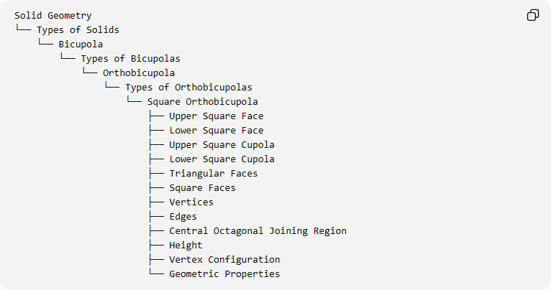
Solid Geometry
└── Types of Solids
└── Bicupola
└── Types of Bicupolas
└── Orthobicupola
└── Types of Orthobicupolas
└── Square Orthobicupola
├── Upper Square Face
├── Lower Square Face
├── Upper Square Cupola
├── Lower Square Cupola
├── Triangular Faces
├── Square Faces
├── Vertices
├── Edges
├── Central Octagonal Joining Region
├── Height
├── Vertex Configuration
└── Geometric Properties

Key Points
# Source: AI Source: Provided by: [Data Path: Persons Table -> ID Column: 1, Name_En Column: Motasem Essam] -> From: [ChatGPT] on [7/25/2026]
- The Square Orthobicupola is Johnson solid $J_{28}$.
- It is formed by joining two square cupolas at their octagonal bases.
- It has 8 equilateral triangular faces and 10 square faces.
- It contains 18 faces, 32 edges, and 16 vertices.
- Its two cupolas have aligned orientations.
- Its symmetry group is $D_{4h}$.
- It is distinct from the Square Gyrobicupola (J29).

Conclusion
# Source: AI Source: Provided by: [Data Path: Persons Table -> ID Column: 1, Name_En Column: Motasem Essam] -> From: [ChatGPT] on [7/25/2026]
The Square Orthobicupola is a convex Johnson solid constructed by joining two identically oriented square cupolas at their octagonal bases. Its external structure consists of eight equilateral triangular faces and ten square faces, making it the 28th solid in the Johnson-solid classification.

